

**The Health Centre**

**Victoria Road  
 Hartlepool**

**TS26 8DF**

**🕿 01429 273191**

**email –** [**nencicb-tv.a81060@nhs.net**](mailto:nencicb-tv.a81060@nhs.net)

**website –** [**www.drskohandtrory.co.uk**](http://www.drskohandtrory.co.uk)

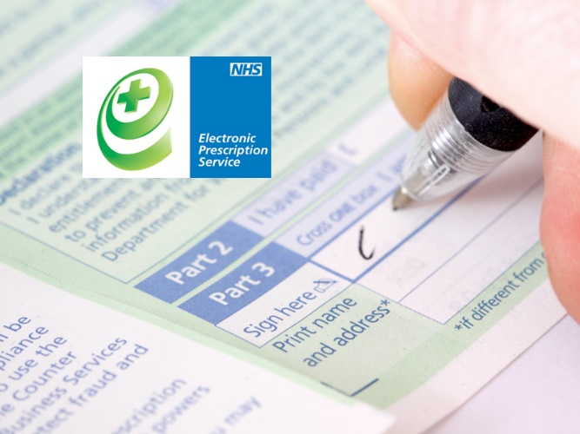

Drs Koh & Trory

Patient Leaflet

**Electronic Prescription Service (EPS)**

**Electronic Prescriptions**

Most prescriptions are now signed, sent and processed electronically.

You have two choices for how this works.

1. You can choose a Pharmacy to dispense all your prescriptions. When you get a prescription, it will be sent electronically to the Pharmacy you have chosen. You can collect your medicines or appliances without having to hand in a paper prescription.
2. You can decide each time you are issued a prescription where you would like it to be dispensed. When you are issued a prescription, you will be given a paper copy that you can take to any Pharmacy or other dispenser in England. The paper copy will contain a unique barcode that will be scanned to download your prescription from the secure NHS database.

Paper prescriptions will continue to be available in special circumstances, but almost all prescriptions will be processed electronically.

## **Choosing a Pharmacy or other dispenser**

If you get regular prescriptions or are already using a prescription collection service (where a Pharmacy collects prescriptions from your GP Practice for you) then choosing a Pharmacy to dispense all your prescriptions may save you time by avoiding unnecessary trips to your GP.

You will still order your repeat prescriptions in the same way as you do now, but your prescriptions will be sent electronically to the Pharmacy of your choice.

You will not have to collect a paper repeat prescription from your GP Practice.

## **Cancelling or changing your choice of pharmacist or dispenser**

You can change or cancel your choice of Pharmacy at any time. Simply speak to your GP or Pharmacist before you order your next prescription.

You should allow time for the update to take place to avoid your next prescription being sent to the wrong place.

## **What can I do if I'm unhappy with the process?**

You should be provided with information about electronic prescriptions service and give your consent before your choice of dispenser is recorded.

If you are unhappy with your experience, you can complain to the Pharmacy, your GP Practice, or your local Integrated Care Board (ICB).

[How to complain to the NHS - NHS (www.nhs.uk)](https://www.nhs.uk/using-the-nhs/about-the-nhs/how-to-complain-to-the-nhs/)